Assignment 4: International Dataset Interaction with Tableau
Niranjana Sathish Avilery
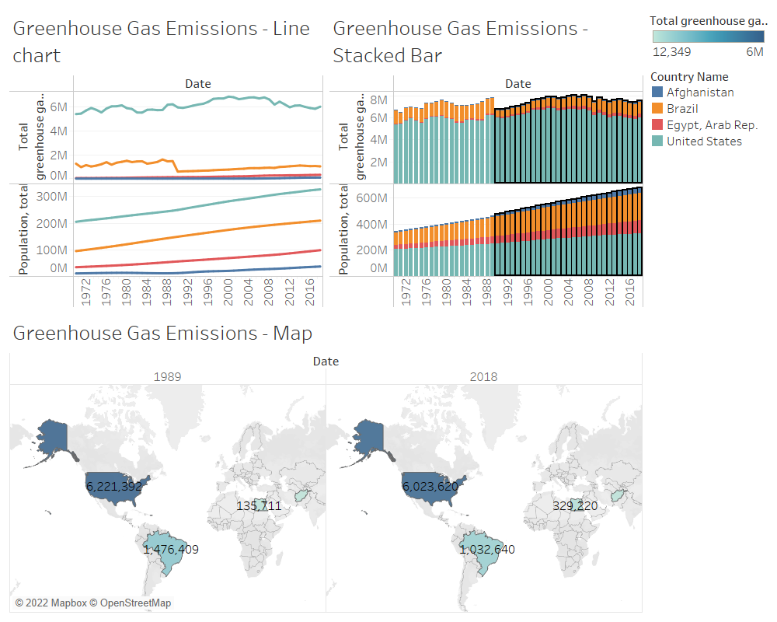
Four Countries:
1. Low-income – Afghanistan
2. Lower-middle-income – Egypt
3. Upper-middle-income – Brazil
4. High-income economies – United States
Selected Indicator:
Total greenhouse gas emissions (kt of CO2 equivalent)
Population, total

Comparison Analysis:
Using the choropleth map and the graphs plotted, it is obvious that the countries highlighted are experiencing an upward trend in Greenhouse gas (GHG) except for Brazil due to the country's reduced deforestation rates. The Brazilian government has implemented a plan to control Amazon deforestation, resulting in a sharp decline in deforestation.[1] This can be seen in the year 1990 (Stacked Bar Chart) where there is a significant drop in emission rate when compared to the previous year. It can be interpreted that the countries that fall under the high (US) and upper-middle-income (Brazil) category emit the most when compared to the other two categories. On the line plot, we can also infer that GHG emissions have steadily increased at a constant rate in low (Afghanistan) and lower-middle-income (Egypt) countries over the last five decades. According to climatelinks[2], it was found that the increase in emissions in Afghanistan is due to agriculture, waste, and industrial processes whereas in Egypt, climateinvestmentfunds[3] mentions fossil fuel-based power and transport sectors as the main reason for the increase. Among the four countries, greenhouse gas emissions were the highest for the United States which totaled 6,023,620 kt of CO2 equivalent. This represents a 9 percent increase since 1970 but a 13 percent decrease since 2005. It can also be seen that there is some correlation between CO2 emission and total population.
Tableau interactive capabilities reflection:
Tableau helps visualize different attributes in the dataset using the drag-and-drop feature which makes it less difficult for anyone can use it without prior knowledge. This makes it easier to navigate between different charts to be able to visualize data with different approaches and provides detailed insights. Tableau also helps highlight specific data (Brushing) in the charts based on filters to help analyze the features for example., it helped visualize the years after a significant drop in greenhouse emissions in this analysis. There were other charts that did not give meaningful insights into this dataset but navigating through different charts helped me understand the correlation between features.
References
[1] “Brazil's GHG emissions fall 39% since 2005, now 10% below 1990 levels,” Mongabay Environmental News, 06-Jun-2013. [Online]. Available: https://news.mongabay.com/2013/06/brazils-ghg-emissions-fall-39-since-2005-now-10-below-1990-levels/
[2] “Greenhouse gas emissions factsheet: Afghanistan,” Global Climate Change, 31-May-2016. [Online]. Available: https://www.climatelinks.org/resources/greenhouse-gas-emissions-factsheet-afghanistan.
[3] “Egypt,” Climate Investment Funds, 28-Mar-2018. [Online].
Available: https://www.climateinvestmentfunds.org/country/egypt.

